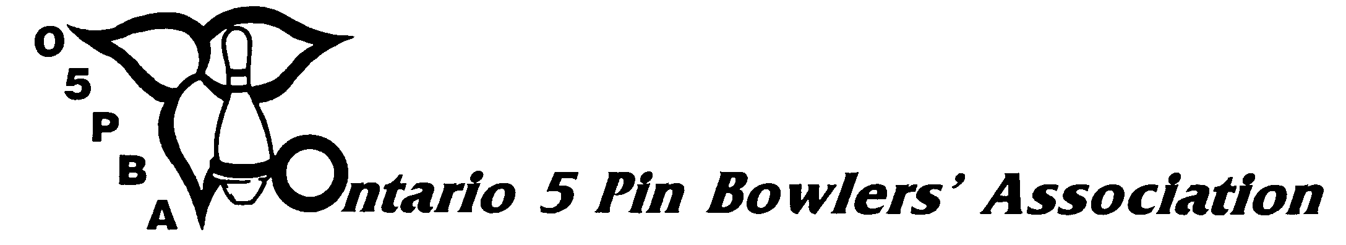
2013/2014 ONTARIO OPEN CHAMPIONSHIPS

DECLARATION OF INTENT

BOWLER COACH BOTH

Date:

To: , Tournament Director
(Name) (Zone)

I, hereby state my intent to bowl/coach in the Zone
(Print Name)

Open Roll-off for the 2013/2014 bowling season in the above named Zone. I am currently, and was during the 2012/2013 season, a registered member of an O5PBA sanctioned or affiliated league in the

League at .
(League Name) (Bowling Centre Name)

I am attaching a copy of my current year (2013-14) average sheet confirming my participation in said league or in another league within that same Association. In the prior season I bowled a minimum of fifty (50) games in a sanctioned or affiliated league of the zone I am declaring in, and I am listed on the o5pba.ca website average book for said league to verify my eligibility to declare. The League Secretary has signed below to indicate that my current average sheet is a true copy. I understand that the cost of a zone shirt may be at my own expense.

(Signature)

I verify that the information for the above named person is true.

(SECRETARY’S NAME) (SECRETARY’S SIGNATURE) (DATE)

NAME: MEMBERSHIP #:
ADDRESS: CITY:
POSTAL CODE: TELEPHONE #: ( )

RECEIVED BY DATE
(Tournament Director)

